OUTPUT 1
GR-ART-0

Name of artwork
A New Land Outside My Window (original title in Swedish: Ett nytt land utanför mitt fönster)

Type of artwork
Novel

Creator
Theodor Kallifatides

Year of creation
2001

Copyright holder
Bonnier Pocket

Artwork extract
His reply had filled me with happiness about being Greek, or more precisely at being back in the Greek language. I kept repeating to myself: "When the sea turns to yogurt, that's when the poor man finds he has no spoon."

I smiled happily to myself, as if remembering something agreeable. Then it struck me that that was exactly right. From being central to my life, the Greek language had become just a memory.

I no longer had any real empathy with my language. I recognised that. But after a 36-year absence, I was beginning to discover it anew. That was a blessing.
My lips moved effortlessly, my voice sank deeper within my chest, like a diver hunting for hidden treasure.

I don't know what else I can say to describe the feeling I experienced. But let me try once more. It was as if I were falling. The fall seemed long and inevitable, when suddenly it was being slowed down by a self-opening parachute.

I would never lose my way as long as the homely hearth of my language was still glowing, even if at a distance.

I would die with my dignity intact. No one can be more safe and secure than one who possesses a language.

Image (if available)
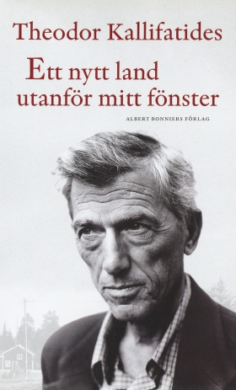

Description (in English and national language)
The book is about Theodor Kallifatides' reflections on what happened to him after thirty-six years of life as a stranger. Kallifatides talking about even aging, alienation, both for the environment and their own individual, and how fundamentally different it is from the phenomenon of aging as a stranger, which places an emphasis on alienation and not aging itself. He notifies the reader of the fact that to live as a foreigner means to live with people who do not know one, and how it can affect both the environment as an individual, and that alienation which also can be / is used as a protection against excessive symbiotic relationship, ie be a fundamental requirement for getting / given space to be themselves. If alienation from both positive and negative point of view, and the latter's impact on both their own individual as the surroundings.
This excerpt from the book, dealing with the power of mother language for immigrants. It described as helping them to keep a tie with their roots.

Age of users
Primary
Secondary
Adult

